**Academic English Guide**

Phase #2 – From March 26th to April 3rd.

**Valerie Ayala**

**Student:** _____________________________________ **Grade:** 10-11th. Grade **English Level:** C1

**GENERAL INSTRUCTIONS**

* The assigned work will be divided into the four language areas that we exercise on a regular basis in class (Listening, Reading, Writing & Grammar). Every language area will have an assigned grade and a specific rubric for its revision.
* The objective is to exercise them throughout the week and deliver the final product to the latest on **April 3rd** by email to the following address:

[nivelmedio-ingleszacapa@colegioverbo.edu.gt](mailto:---------@colegioverbo.edu.gt)

* Save your document like this: **Student´s name­_10th Grade_English Guide**
* This guide must be presented identified with name, grade and level the student belongs to.
* If necessary, insert text boxes in order to identify and fulfill your work.
* Remember to apply the appropriate use of grammar, spelling, punctuation and capitalization rules in each activity you do.

|  |  |
| --- | --- |
| **Contents** | **Christian Philosophy** |
| * Vocabulary Builder * Reading about “Biggest cities” * Article * Future tenses | * **Bible Principle:** Christian Character * **Bible verse:** Genesis 24:11 * **Value:** Loyalty |

**VOCABULARY AND LISTENING**

**Instructions:** Watch out the chart below, then search the definitions of the words in the internet and write them down.

|  |  |
| --- | --- |
| Widowed | Lose one’s spouse through death |
| Childhood | The age span ranging from birth to adolescence |
| Engagement | A formal agreement to get married |
| Marriage | The legally recognized union of two people as partners in a personal relationship |
| Spoiled | Harmed in character by being treated too leniently or indulgently |
| Shrine | A place regarded as holy because of its associations with divinity or a scared person or relic |
| Abduct | Take away illegally by force or deception |
| Measure | Ascertain the size, amount, or degree of something by using an instrument |

**Instructions:** Choose 5 words from the list and do the following:

1. 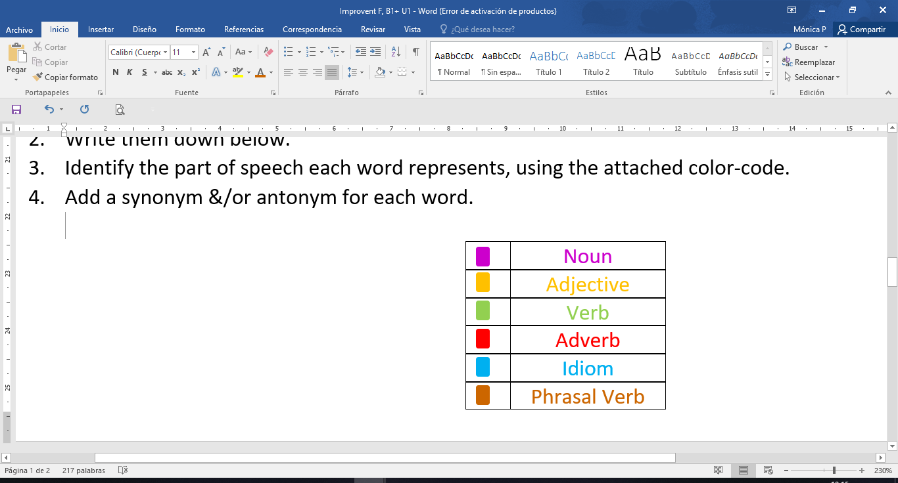List words in alphabetical order.
2. Identify the part of speech each word represents by using the attached color-code.
3. Add a synonym for each word.
4. Write one sentence applying each word.
5. **Abduct – kidnap : The man abducted the kids.**
6. **Childhood- youth : I lived my childhood in the USA**
7. **Marriage-union : Marriage is a very important part to every relationship.**
8. **Measure-calculate: Can you measure the table please.**
9. **Spoiled- pamper: My mom spoiled my little sister.**

|  |  |  |  |
| --- | --- | --- | --- |
| **Criteria** | **Evidence** | **No Evidence** | **Observations** |
| Lists the required words in alphabetical order. |  |  |  |
| Appropriately identifies the parts of speech by using the given color code. |  |  |  |
| Writes a synonym and antonym for each word. |  |  |  |
| Appropriately use of grammar and spelling. |  |  |  |
| Presents an example for each word through meaningful images. |  |  |  |
| **Total** | **/** | | |

**Vocabulary Checklist**

**READING**

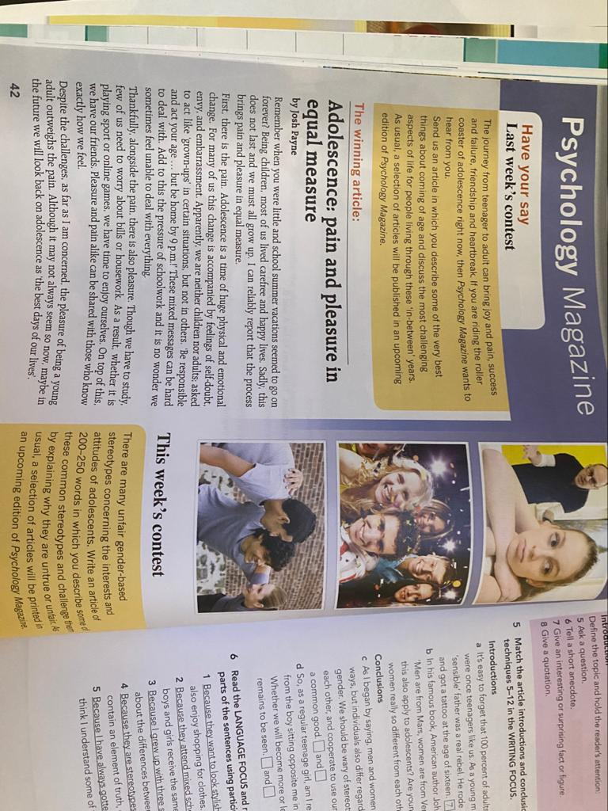**Instructions:** Read the text and complete the tips for writing an article with the words in the box.

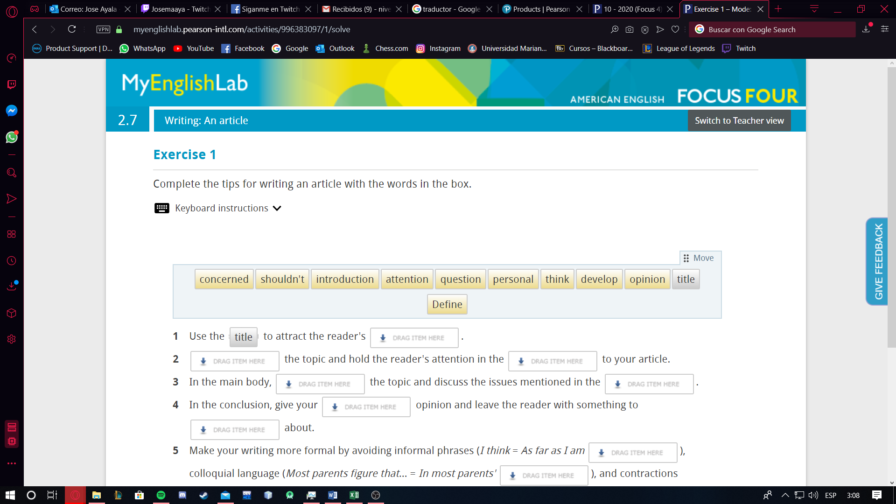

1. Use the ***TITLE*** to attract the reader's __**ATTENTION** ______________ .
2. __**DEFINE** ______________ the topic and hold the reader's attention in the __**INTRODUCTION** ______________ to your article.
3. In the main body, __**DEVELOP**______________ the topic and discuss the issues mentioned in the __**QUESTION**______________.
4. In the conclusion, give your _**PERSONAL**_______________ opinion and leave the reader with something to ___**THINK**_____________ about.
5. Make your writing more formal by avoiding informal phrases (I think = As far as I am __**CONCERNED**______________), colloquial language (Most parents figure that… = In most parents' ___**OPINION**_____________), and contractions (___**SHOULDN’T**_____________= should not).

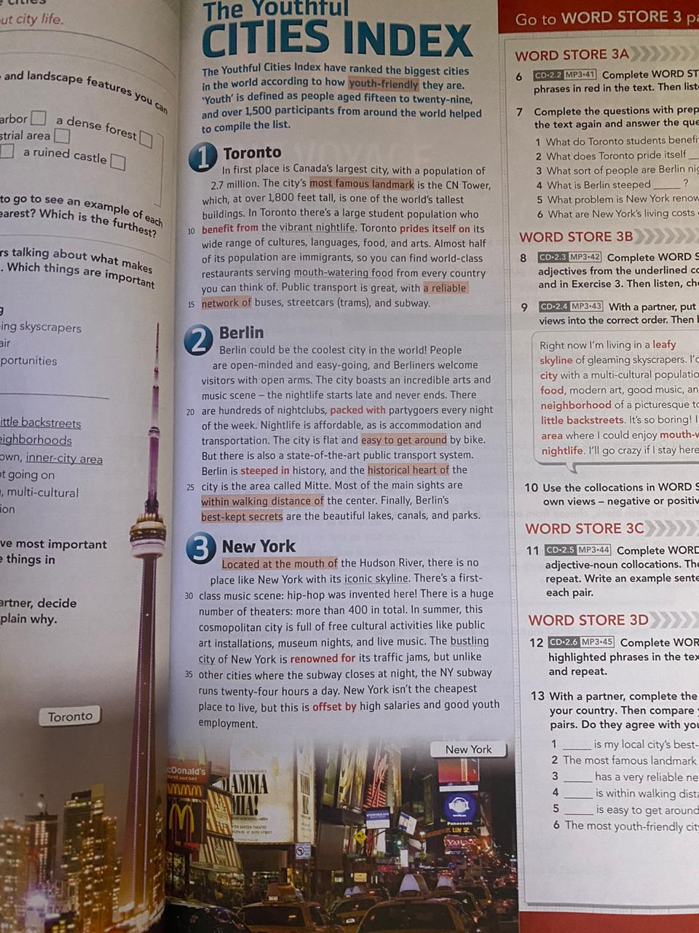

**Instructions:** Read the lecture “The Youthful Cities Index” and complete a graphic organizer with the biggest cities in the world (write the title in the middle example “TOP 5 BIGGEST CITIES)

* Include name
* Include population
* Include country

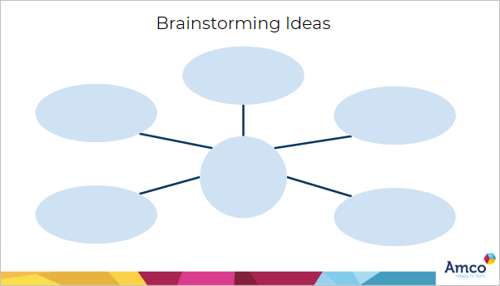

* Toronto
* 2.7 million
* Canada
* New York
* 8.632 million
* United States

TOP 5 BIGGEST CITIES

* Berlin
* 3.769 million
* Germany

**WRITING**

**Instructions:** Read the task below. Before you start writing, note down some ideas and plan your piece of writing. Then write an article. Include at least one sentence with a participle clause.  
  
Write an article of 140–190 words for your school's website. Describe the beginning of the friendship with your best friend and explain the role of friendship for young people as they grow up.

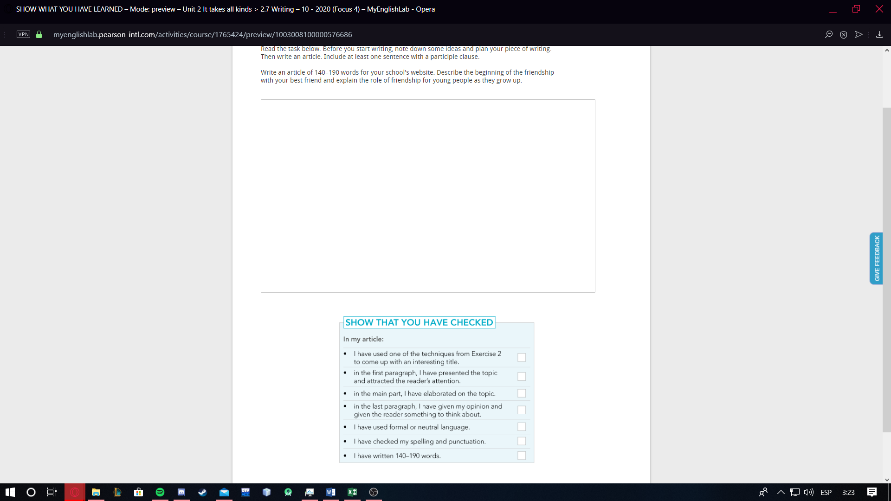

My best friend and I

Last year I came back from my trip and I finally went to school. And I found out that there were a lot of new kids. In that group of new kids I found a really special girl her name is Carla Daniela. We started being friends and after that we started getting closer and getting to know more about each other. At first I thought that she was mean but with time I found out that she’s the most caring, patient, and sweet girl. So I consider her like my best friend because she knows a lot about me like basically everything and I trust her so much. I know I can tell her anything and I wouldn’t be scared of being judged. Any problem that I have she helps me and it doesn’t matter what it is. I can say that I’ve never had a friend like her. We also compliment our friendship very good. She’s a really good listener and patient and I talk a lot and I say things they way they are. I think that our friendship is very strong and I really hope it stays like that because I don’t think I could live without my bestfriend.<3

* **Instructions:** Watch the following video in YouTube through this link: <https://youtu.be/SOCixRhRGDw>

Then create a graphic organizer with the most important information that is in the video

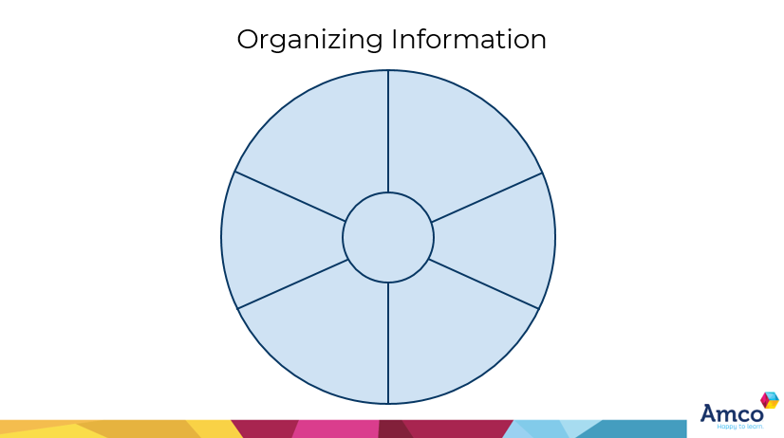

Astronauts are carried up into space by rockets.

The space station use solar panels to provide energy

They do experimetns and excersise every day to keep their muscles in shape

Astronauts don´t take baths

To go home, they use space capsules

In the space station there is less gravity

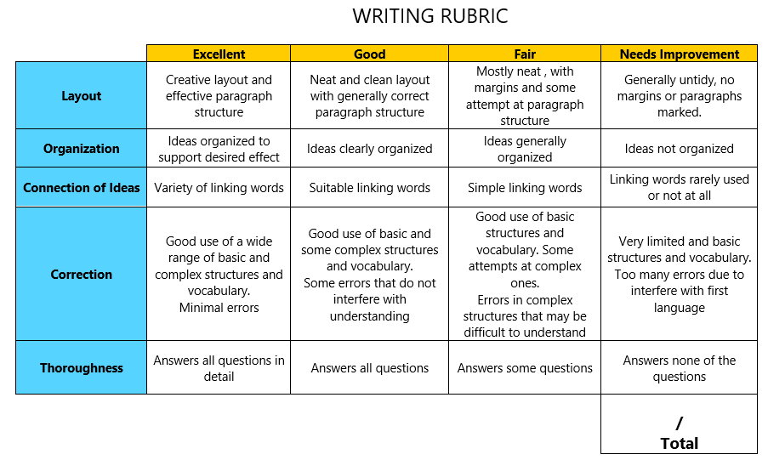

**GRAMMAR**

**Instructions:**

* Watch the following video in YouTube through this link to learn about future perfect: <https://www.youtube.com/watch?v=rcxytsa8CbI>
* Watch the following video in YouTube through this link to learn about future perfect progressive: <https://youtu.be/HPz_5NXh91E>
* Watch the following video in YouTube through this link to learn about future perfect progressive: <https://youtu.be/GxMy-7-IbGs>
* Then, create a comparative chart between the three uses including, rules/use, structures and examples

|  |  |  |  |
| --- | --- | --- | --- |
| INCLUDING | FUTURE PROGRESSIVE | FUTURE PERFECT | FUTURE PERFECT PROGRESSIVE |
| RULES/USE:  STRUCTURES:  +  -  ?  EXAMPLES  +  +  -  -  ?  ? | 1.Actions that will be happening at a certain time in the future.  2.Actions which will be interrupted by another one.  1.Subject + will + be + verb in present participle  2.Subject + will not + be + verb in present participle  3.Will + subject + be + verb in present participle  1.julio will be studying when he get his boks.  2.you will be loving Chinese food  1.He will not be graduating next year.  2.Skinny will not be barking noisily when we arrive.  1.will she be singing when we arrive?  2.will carry be loving the cake while she will eat? | It shows that an action will continue up until certain period of time or event in the future.  1.Subject + will + have been + past participle.  2.Subject + won´t + have been + past participle.  3.Will + subject + have been + verb in present participle.  1.I will have been studying college by the time my dad let me have my own apartament.  2.Your dog will have been dying of hunger by the time u feed it.  1. I won´t have been studying college by the time my dad let me have my own apartament.  2. your dog won´t have been dying by the time u feed it.  1.will I have been studying college by the time I have my own house?  2.will your dog have been dying till u feed it? | 1.Actions that finished before another action.  2.Something that still happening in the future.  1.Subject + will + have + past participle verb  2.Subject + will not + have + past participle verb  3.Will + subject + have + past participle  1.They will have bought a new house.  2. I will have known that topic.  1.I wont have seen that movie  2.she wont have gone to the house yet.  1.Will I have finished the repot?  2.Will you have done the homework? |

